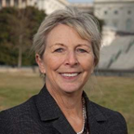
Sara Wyant: Founder and Editor, Agri-Pulse
Sara Wyant is President and CEO of Agri-Pulse Communications, Inc., an electronic publishing company with the largest and most experienced editorial team covering agriculture and food policy issues in Washington, D.C. The firm’s subscription-only products and website, Agri-Pulse.com, Include the latest updates on farm policy, commodity and conservation programs, trade, nutrition, food safety, rural development, and environmental and regulatory programs. She has led numerous boards and is currently President of the National Association of Farm Broadcasters (NAFB) Foundation. A graduate of Iowa State University, Wyant grew up on a Century farm near Marengo, Iowa which she now owns. She and her husband also own the farm where her husband's family originally established a homestead near Almont, North Dakota.

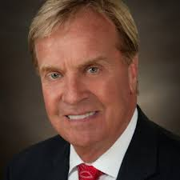
Kip Tom: Ambassador, U.S. Mission to the UN Agencies in Rome
Kip Tom is the United States Permanent Representative to the United Nations Agencies for Food and Agriculture in Rome, with the Rank of Ambassador. Ambassador Tom was confirmed by the U.S. Senate on April 11, 2019. Ambassador Tom is an agribusiness leader who transformed a seventh-generation farm into a successful farm operation in the Midwest, while launching international operations and deploying new technologies. Ambassador Tom grew up on his family’s farm in the community that his ancestors homesteaded in 1837. He previously served as a member of the board of the Indiana Economic Development Corporation. He has been involved in several philanthropic organizations focusing on food security and development issues domestically and globally. He is also active in supporting the next generations of farmers, having served as a trustee of the National 4-H Foundation and a member of the National Future Farmers of America Foundation Board of Directors. Ambassador Tom holds an advanced management certificate from Texas A&M in agriculture economics.

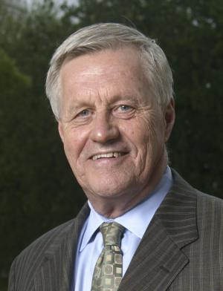
Rep. Collin Peterson: Chairman of the House Agriculture Committee
Collin Peterson was first elected to the U.S. House of Representatives from the Seventh Congressional District of Minnesota in 1990 and is currently Chairman of the House Committee on Agriculture. Peterson also serves on the Veterans' Affairs Committee. Congressman Peterson grew up on a farm near Glyndon, Minnesota and graduated from Minnesota State University-Moorhead in 1966 with a double major in Business Administration and Accounting. He served in the North Dakota National Guard from 1963 to 1969. Before being elected to the House of Representatives, he was a Certified Public Accountant and small business owner in Detroit Lakes, Minnesota, and served for ten years in the Minnesota State Senate. He is a founding member of the conservative Democrats’ “Blue Dog” Coalition, which continues to be a voice for fiscal responsibility and pragmatic government policies.

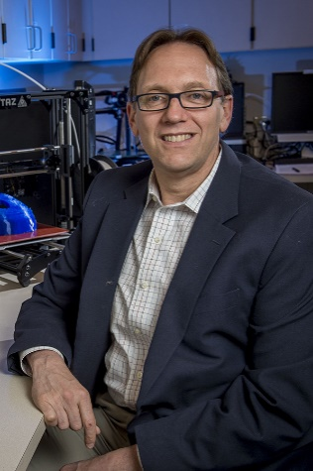
Dr. Alan S. Rudolph: Vice President for Research at Colorado State University
Dr. Alan Rudolph serves as the Vice President for Research at Colorado State University. Dr. Rudolph is a former member of the Senior Executive Service, having served as the Director for Chemical and Biological Technologies Directorate, Research and Development Enterprise, Defense Threat Reduction Agency (DTRA). As a National Research Council postdoctoral fellow, his earliest work at the U.S. Naval Research Laboratory (NRL) demonstrated the translational value of strategies used by organisms that survive environmental extremes to preserve defense products such as biosensors and blood products for field deployment. After a decade at NRL, he joined the Defense Advanced Research Projects Agency (DARPA) to lead new strategic efforts to extract and exploit useful principles and practices in life sciences and technology and establish an agency-wide strategy for investments in biosciences and biotechnology. As Chief of Biological Sciences and Technology, Dr. Rudolph established a framework for investments that continues today. He received a meritorious civil service citation from the Office of the Secretary of Defense for his contributions to defining and implementing a new generation of life sciences and national security investments. In 2003, he left civil service for the private sector and to start new corporate biotechnology efforts, working as Chief Executive Officer of Adlyfe, Inc., a diagnostic platform company, and Board Chairman of Cellphire, Inc.

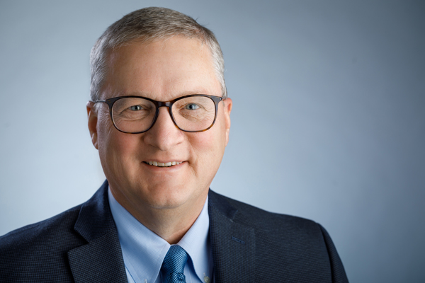
Everett Hoekstra: President, U.S. Animal Health, Boehringer Ingelheim
Hoekstra oversees the company’s largest animal health market and helps drive continued growth and innovation in an industry undergoing significant change due to consolidation and technological advances. Hoekstra has held a variety of leadership roles since joining Boehringer Ingelheim in 1997, mainly in finance at the company’s human pharmaceutical business. He also co-led the launch of Boehringer Ingelheim’s global diabetes alliance with Eli Lilly and Company and most recently served as chief financial officer of the U.S. animal health business. A native of Iowa, Hoekstra spent 12 years early in his career as co-owner and business manager for a veterinary group in the Midwest. As part of that group, he helped build several successful veterinary agriculture businesses, including a swine biologics business (today part of Boehringer Ingelheim), a veterinary distribution company (today part of Animal Health International of the Patterson group of companies), and a bovine reproductive technology services company (Trans Ova Genetics). He is a graduate of Dordt College.
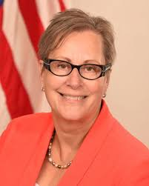
Dr. Liz Wagstrom: Chief Veterinarian, National Pork Producers Council

Liz Wagstrom, DVM, is the National Pork Producers Council’s chief veterinarian. Wagstrom worked at the Pork Board first as director of Veterinary Services and more recently as assistant vice president for Science and Technology. Of late, she was an associate professor with the University of Minnesota’s Center for Animal Health and Food Safety. She has also served as an epidemiologist and public health veterinarian for the Minnesota Department of Health. Wagstrom has broad experience in domestic and international animal health and welfare, on-farm production and public health and food safety issues,
working at the interface of animal and public health and led the initial development of the industry’s programs on responsible use of antibiotics. Dr. Wagstrom has been an industry consultant to the Public Health Action Plan to Combat Antimicrobial Resistance as well as served as an Advisory Board member to CDC’s “Get Smart on the Farm” initiative. Dr. Wagstrom currently serves on the Association of American Veterinary Medical Colleges and Association of Public and Land-Grant Universities’ Task Force on Antibiotic Resistance in Production Agriculture. She has made numerous presentations to U.S. and international audiences on the responsible use of antibiotics in animal agriculture.
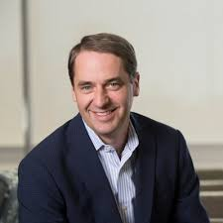
Jeff Simmons: President and CEO, Elanco
Jeff Simmons serves as president and chief executive officer of Elanco Animal Health. A global leader with a 65-year track record of growth, Elanco provides comprehensive products and knowledge services to improve animal health, welfare, and food animal production with 125 brands in 90 countries. Jeff is a purpose-driven leader with nearly 30 years of experience focused on delivering business results while engaging employees and developing the next generation of leaders. As the head of Elanco Animal Health for the past decade, Jeff has directed the company’s transformation from a primarily U.S. feed additive company to a premier global player with a diversified business. During Simmons’ tenure, Elanco has tripled in size, created a unique innovation engine, completed 12 acquisitions, and built five new businesses, including a $1 billion companion animal business and a leading aquaculture business. In 2018, Simmons navigated the company's separation from Lilly, culminating with Elanco's listing on the New York Stock Exchange as the second largest independent animal health company. Most recently, he has orchestrated the company's acquisition of companion animal startup Aratana and the pending acquisition of Bayer's Animal Health business.

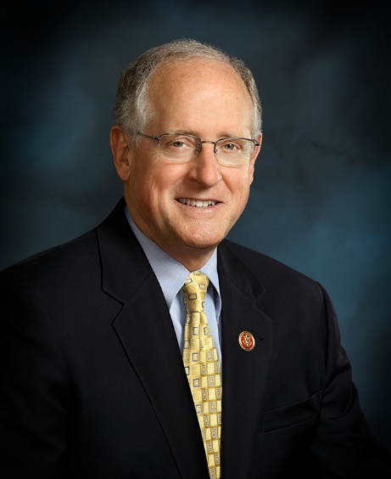
Rep. Michael K. Conaway: Ranking Member, House Committee on Agriculture

Serving his eighth term in the U.S. House of Representatives, Congressman Mike Conaway represents 29 counties in Texas’ 11th congressional district, including the cities of Midland, Odessa, and San Angelo. In the House, Congressman Conaway is the Ranking Member of the House Committee on Agriculture and serves on the House Armed Services Committee and the Permanent Select Committee on Intelligence. He is a deputy Republican whip, a position he has held since the 112th Congress. A native Texan, he grew up in Odessa and graduated from Odessa Permian High School in 1966 after playing on Permian’s first state championship football team. He earned a Bachelor of Business Administration degree in accounting from Texas A & M University-Commerce in 1970. After serving in the Army at Fort Hood, he returned to the Permian Basin with Price Waterhouse and settled in Midland, later working with George W. Bush as the chief financial officer for Bush Exploration. An ordained deacon in the Baptist church, Congressman Conaway and his wife, Suzanne, live in Midland and have four children and seven grandchildren.
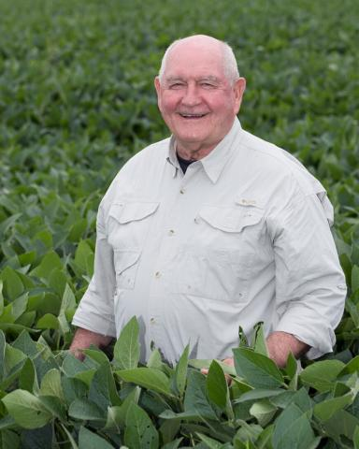
Sonny Perdue: Secretary of Agriculture, USDA
Sonny Perdue is a former farmer, agribusinessman, veterinarian, state legislator, and governor of Georgia. He became the 31st United States Secretary of Agriculture on April 25, 2017. The work ethic cemented in him by his farming roots has remained with Sonny Perdue throughout his life. As a younger man, he served his country in the U.S. Air Force, rising to the rank of Captain. After earning a Doctor of Veterinary Medicine from the University of Georgia, he put that training to use in private practice in North Carolina. As a member of the Georgia State Senate for eleven years, he eventually ascended to the position of President Pro Tempore as elected by his senate colleagues. As a two-term governor of Georgia, he was credited with transforming a budget deficit into a surplus, dramatically increasing the student performance in public schools, and fostering an economic environment that allowed employers to flourish and manufacturers and agricultural producers to achieve record levels of exports. He followed these accomplishments with a successful career in agribusiness, where he focused on commodities and transportation in enterprises that have spanned the southeastern United States. He is acknowledged as a national leader in agriculture, having served as a board member for the National Grain & Feed Association, and as president of both the Georgia Feed and Grain Association and the Southeastern Feed and Grain Association. Perdue has long-standing, close relationships with the leadership of the American Farm Bureau and has been recognized by the Georgia 4-H and FFA programs, among others, for his leadership in agriculture.
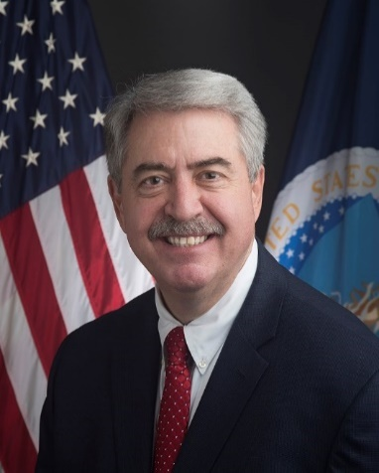
Ted McKinney: Under Secretary of Agriculture for Trade and Foreign Agricultural Affairs, USDA
Ted McKinney currently serves as Under Secretary of Agriculture for Trade and Foreign Agricultural Affairs. Prior to assuming his current position, McKinney served as director of the Indiana State Department of Agriculture from 2014 to 2017. Before serving as director, McKinney worked for 19 years with Dow AgroSciences, and 14 years with Elanco, a subsidiary of Eli Lilly and Company, where he was Director of Global Corporate Affairs. He has served on the National FFA Convention’s Local Organizing Committee, Indiana State Fair Commission, International Food Information Council, the U.S. Meat Export Federation, International Federation of Animal Health, and the Purdue Dean of Agriculture Advisory Committee. McKinney grew up on a family farm in Tipton, Indiana. He was active in 4-H and the National FFA Organization. In 1981, he received a B.A. in agricultural economics from Purdue University.

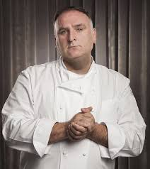
José Andrés: Chef and Founder, World Central Kitchen
Twice named to Time’s “100 Most Influential People” list and recipient of the 2015 National Humanities Medal, José Andrés is an internationally-recognized culinary innovator, New York Times best-selling author, educator, humanitarian, and chef and owner of Think Food Group, the award-winning collective of nearly thirty restaurants throughout the country and beyond. In 2010, Andrés founded World Central Kitchen, a non-profit specializing in delivering food relief in the wake of natural and humanitarian disasters. Notably, his team served 3.7 million meals to the people of Puerto Rico following Hurricane Maria and has since served more than 40 million meals worldwide. In response to the COVID-19 pandemic, WCK has partnered with restaurants, small farms, and local partners around the country to combat food insecurity. A naturalized U.S. citizen originally from Spain, Andrés has been a tireless advocate for immigration reform and on July 4, 2014 was named by President Barack Obama as that year’s “Outstanding American by Choice.”
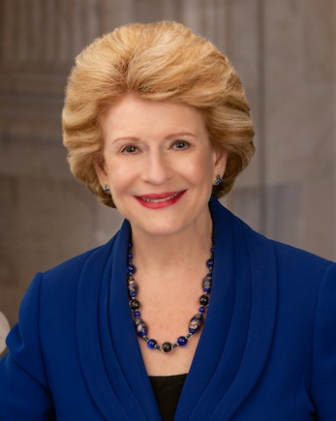
Sen. Debbie Stabenow: Ranking Member, Senate Committee on Agriculture
Senator Debbie Stabenow of Michigan serves as Ranking Member of the Senate Agriculture, Nutrition and Forestry Committee, where she is leading the effort for improving sustainability in food and agriculture. In the 2018 Farm Bill, she authored the most advanced climate-smart agriculture policies to date. Earlier this year, she partnered with Senator Mike Braun of Indiana to introduce the bipartisan Growing Climate Solutions Act, which helps farmers and foresters scale up sustainable practices and tap into new economic opportunities through voluntary carbon markets. Senator Stabenow also serves as a senior member of the Senate Energy and Natural Resources Committee, the Senate Finance Committee, and the Senate Budget Committee. Born and raised in Michigan, Stabenow served in the Michigan House of Representatives for twelve years and the State Senate for four years. Stabenow was first elected to serve in the U.S. House of Representatives in 1996 and was elected to the United States Senate in 2000.
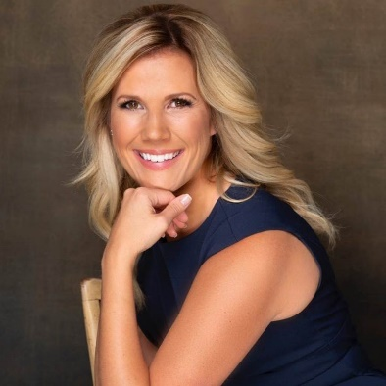
Laura Wood Peterson: Senior Director, Government Affairs, Indigo Agriculture

Laura Wood Peterson is the Senior Director, Government Affairs for Indigo Agriculture. Prior to this role, she served as Head of Federal Government and Industry Relations for Syngenta and Director of Federal Affairs for the National Association of Conservation Districts. She has experience in agriculture lobbying with The Russell Group as well as multiple internships in the Kansas Legislature, United States Congress and U.S. Senate Committee on the Judiciary. She is a member of the Kansas Bar and American Bar Associations and attended Kansas State University and George Washington University Law School, where she taught American Politics as adjunct faculty in the Undergraduate Political Science Department. Laura grew up on a family farm in Kansas and co-operates an angus cattle herd in Eastern Montana with her husband, Jess. She is on the board of the Conservation Technology Information Center and Montana Conservation Voters.
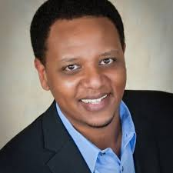
Teddy Bekele: Chief Technology Officer, Land O’Lakes
Bekele has a passion for researching, developing, and implementing innovative technology solutions to help agricultural retailers and farmers produce more nutritious food while optimizing their business and safeguarding natural resources. Working within Land O'Lakes, Teddy works to bolster the cooperative’s unique farmer-to-fork perspective with insights and visibility into all aspects of food, from the seed planted to the food we eat. Teddy regularly speaks on technology in agriculture, including appearances at SXSW and Google Next on the utilization of technology to optimize farming decisions. Teddy was born in Ethiopia and moved to Italy in 1985, finally immigrating to the United States in 1993. He holds an MBA from Indiana University and a Bachelor of Science in Mechanical Engineering from North Carolina State University.

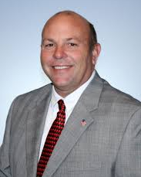
Zippy Duvall: President, American Farm Bureau Federation
Duvall is a third-generation farmer from Georgia who has served as President of the American Farm Bureau Federation since January 2016. In addition to a 400-head beef cow herd for which he grows his own hay, Duvall also grows more than 750,000 broilers per year. Prior to being elected AFBF president, Duvall served for nine years as president of the Georgia Farm Bureau. Duvall’s long leadership history in his home state includes service on the Georgia Farm Bureau Young Farmers Committee and Georgia Farm Bureau board of directors. He was also recognized with several state appointments, including then-Georgia Gov. Sonny Perdue’s Agricultural Advisory Committee and the Georgia Development Authority. His many state honors include Georgia Dairy Family of the Year. As GFB president, Duvall’s service on the AFBF board of directors included roles on the Trade Advisory Committee, including several international trade missions, and on the Finance Committee. In 2017, Duvall was honored by National 4-H Council as a founding luminary, an exclusive group of accomplished and influential 4-H alumni. Duvall and his late wife, Bonnie, were married for more than 40 years, raised four children, and welcomed five grandchildren. Zippy Duvall is a member of New Hope Baptist Church in Greshamville, Georgia, where he serves as a deacon.
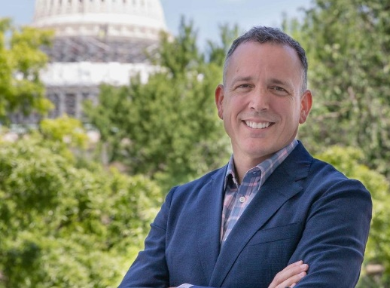
Rob Larew: President, National Farmers Union
Rob Larew was elected National Farmers Union’s 15th president during the organization’s 118th anniversary convention in 2020. He previously serviced as NFU’s Senior Vice President of Public Policy and Communications, advocating for family farmers, ranchers, and rural communities in Congress and the executive branch. Prior to his employment with NFU, Larew served over 22 years in Congress and USDA working on agriculture policy and communication. Most recently he was the staff director of the House Committee on Agriculture where he oversaw the committee’s efforts during the 2008 and 20014 farm bills. He previously served as the Director of Congressional and Public Affairs at the Food Safety and Inspection Service at USDA and worked as an agricultural aide to Rep. Collin Peterson and the late Sen. Paul Wellstone. Larew was raised on a dairy farm in Greenville, West Virginia. He graduated from Virginia Polytechnic Institute and State University with a Bachelor of Science in Dairy Science and completed graduate work in Agronomy at Pennsylvania State University.

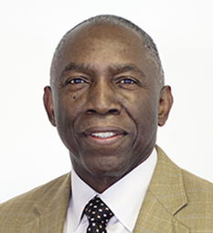
William E. (Kip) Ward: Retired U.S. Army General Officer and Former President of Sentel Corporation of Alexandria, VA
William E. Ward served as the inaugural Commander of the United States Africa Command (AFRICOM), successfully establishing what was then the nation’s newest and most uniquely-positioned interagency geographic command responsible for all U.S. defense and security activities on the African continent and its island nations. Prior to commanding AFRICOM where his visionary leadership promoted the value of forging relationships, creating partnerships, enhancing regional cooperation and the importance of sustained security engagement in pursuing U.S. national interests, Ward was the Deputy Commander, United States European Command (EUCOM), responsible for the Command’s day to day activities. Ward is a decorated combat veteran and holds a Bachelor of Arts Degree in Political Science from Morgan State University in Baltimore and a Master of Arts Degree in Political Science from The Pennsylvania State University. A Master Paratrooper, he is a graduate of the Infantry Officer Basic and Advanced courses, Fort Benning, Georgia, the U.S. Army Command and General Staff College, Fort Leavenworth, Kansas, and the U.S. Army War College, Carlisle Barracks, Pennsylvania. General Ward was an assistant professor, Department of Social Sciences, teaching political science and public policy at the United States Military Academy, West Point. He has held other key Army, Joint and Combined command and staff assignments over a distinguished 40-plus-year career including NATO Stabilization Force Commander in Bosnia, Commander 25th Infantry Division and Vice Director for Operations, J-3, The Joint Staff, during the September 2001 terror attacks. In the Pentagon, he was at the center of determining and carrying out the U.S. government’s defense and interagency response actions to the attack. He is currently a Director on several non-profit and for-profit boards.

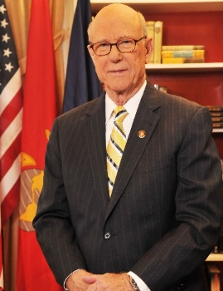
Sen. Pat Roberts: Chairman, Senate Agriculture Committee
Senator Pat Roberts is the only person to serve as both Chairman of the House Agriculture Committee and the Senate Agriculture Committee. He has also served as the ranking member of each committee. With a record number of votes in favor of his bipartisan 2018 Farm Bill, Senator Roberts also becomes the first member of Congress to write and pass a Farm Bill in both chambers. Roberts has been recognized as a leader in food and biosecurity. He held the first hearings on the issue in Congress, has helped pass major biosecurity legislation, assisted Kansas State and other Kansas schools in gaining federal research investments, leading to the Biosecurity Research Institute (BRI) at Kansas State (housed in Pat Roberts Hall). Finally, he led the state’s effort to compete and earn the National Bio and Agro-Defense Facility (NBAF), a new federal laboratory to replace the aging federal plant and animal research facility at Plum Island. He previously served as the Chairman of the Senate Select Committee on Intelligence. Born in Topeka, Kansas, Roberts graduated from Kansas State University with a degree in journalism. He served as a captain in the Marines and worked as a newspaper reporter before entering politics in the late 1960s. He was elected to the House in 1980 and, for 16 years, he represented the Big First District, including his home of Dodge City, in the U.S. House of Representatives. In 1996, he was elected to the U.S. Senate. He is currently serving his fourth term.

